Advanced Phishing Website Detection using Machine Learning and Ensemble Techniques
VARSHITHA R
Chanakya University , Global Campus on NH-648, Haraluru near Kempegowda International Airport (BIAL) in Devanahalli, Bengaluru, Karnataka (562165)

- Abstract
Phishing attacks are among the most serious cybersecurity threats affecting online users and organizations by creating fake websites to steal sensitive information such as usernames, passwords, and financial data. Traditional phishing detection methods are often ineffective against evolving attack techniques, creating the need for intelligent and automated detection systems. This research extends the existing K-Nearest Neighbor (KNN)-based phishing detection model by integrating advanced Machine Learning algorithms and optimization techniques to improve detection accuracy and system performance. In addition to KNN, the proposed system implements Logistic Regression, Decision Tree, Random Forest, Support Vector Machine (SVM), Gradient Boosting, Artificial Neural Networks (ANN), and Ensemble Voting classifiers. Advanced extensions including feature scaling, hyperparameter tuning using GridSearchCV, Principal Component Analysis (PCA), stratified cross-validation, ROC analysis, confusion matrix visualization, and real-time phishing prediction are also incorporated. Experimental results show that ensemble and boosting-based models achieved more than 97% accuracy, significantly outperforming the original KNN-based phishing detection system.

- Keywords
Phishing Detection, Cybersecurity, Machine Learning, KNN, Random Forest, Ensemble Learning, URL Classification, Artificial Intelligence
- Introduction
Phishing attacks are one of the most common cybersecurity threats affecting individuals, businesses, and financial institutions worldwide. In a phishing attack, cybercriminals create fake websites that imitate legitimate websites to steal sensitive information such as usernames, passwords, banking details, and credit card information. The rapid growth of online banking, e-commerce, and cloud services has significantly increased phishing activities. Traditional phishing detection methods such as blacklist and signature-based techniques are often ineffective because attackers continuously modify URLs, domains, and phishing strategies to bypass security systems. Machine Learning provides an intelligent and automated solution by analyzing phishing-related patterns and classifying websites as legitimate or malicious. The original research paper proposed a K-Nearest Neighbor (KNN)-based phishing detection model using URL classification and achieved an accuracy of 85.08%. However, the model had limitations including limited dataset size, use of only one algorithm, lack of feature engineering, absence of ensemble learning, and limited optimization techniques. This study extends the original work using advanced Machine Learning models and optimization methods to improve phishing detection accuracy significantly.
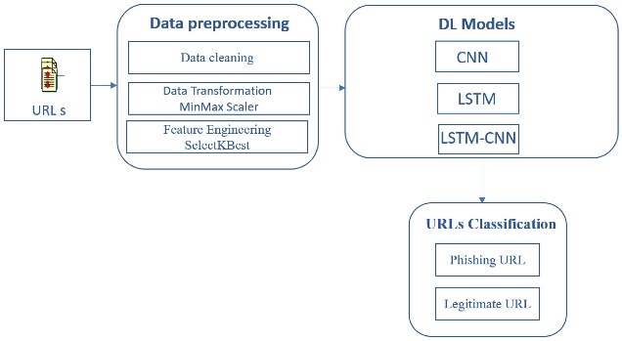
Fig 1. Workflow of phishing website attack and detection system
- Literature Review
Several Machine Learning approaches have been proposed for phishing website detection.
The original study by Tsehay Admassu Assegie proposed a KNN-based phishing detection model using URL classification. The model used 1,353 observations and 10 phishing-related features and achieved 85.08% accuracy.
Previous studies have explored:
- Decision Tree classifiers
- Random Forest
- Support Vector Machine (SVM)
- Deep Learning
- Ensemble classifiers
- Hybrid models
Decision Tree-based phishing detection models demonstrated acceptable classification performance but suffered from overfitting problems. Random Forest models improved phishing detection accuracy using ensemble learning techniques. Deep learning approaches such as CNN and ANN showed promising results but required larger datasets and computational resources.
The reference research paper on heart disease prediction using KNN introduced additional optimization methods including:
- GridSearchCV
- Feature scaling
- Stratified K-Fold Cross Validation
- Distance weighting
- Voting classifiers
These techniques inspired several extensions implemented in this study.

- Research Gap
Although previous phishing detection systems achieved promising results, several challenges still remain:
- Existing systems rely on a single Machine Learning algorithm.
- Limited feature optimization reduces detection accuracy.
- Most studies do not apply hyperparameter tuning.
- Ensemble and boosting methods are not fully explored.
- Real-time phishing prediction is rarely implemented.
- Many models lack comprehensive evaluation techniques.
The original KNN-based phishing detection model achieved only moderate performance and lacked advanced optimization strategies. Therefore, there is a need for a more robust, accurate, and scalable phishing detection framework.

- Proposed Methodology
The proposed methodology extends the original KNN phishing detection system by integrating advanced Machine Learning techniques and optimization strategies.

A. Dataset Collection
The phishing dataset was collected from the Kaggle phishing repository. The dataset contains phishing and legitimate website records with URL-related features such as:
- URL Length
- Having IP Address
- SSL Final State
- Web Traffic
- URL of Anchor
- Request URL
- Domain Age
B. Data Preprocessing
Data preprocessing includes:
- Missing value handling
- Duplicate removal
- Feature scaling using StandardScaler
- Data normalization
Feature scaling improves the performance of distance-based algorithms such as KNN and SVM.
C. Correlation Analysis
A correlation heatmap was generated to analyze relationships between phishing indicators and target labels.

Fig 2. Correlation analysis of phishing dataset features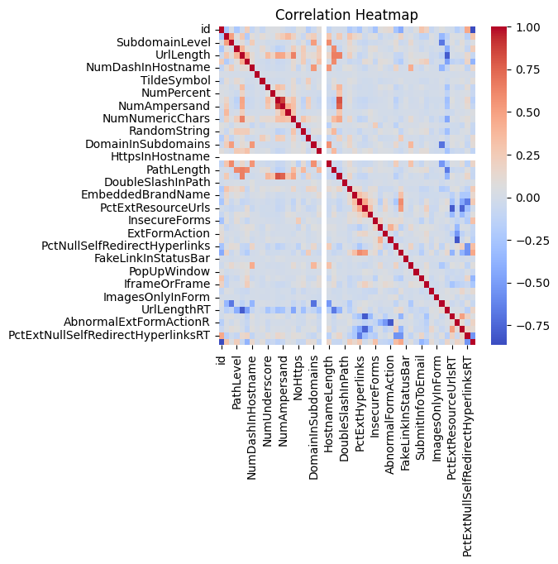
D. Machine Learning Algorithms
The following Machine Learning models were implemented:
Algorithm | Purpose
KNN | Original paper replication
Logistic Regression | Baseline classification
Decision Tree | Rule-based learning
Random Forest | Ensemble classification
SVM | High-dimensional classification
Gradient Boosting | Boosted learning
ANN | Deep learning-based detection
Voting Classifier | Ensemble optimization
E. Hyperparameter Optimization
GridSearchCV was used to determine:
- Optimal K value
- Best distance metric
- Model parameters
The optimized KNN model achieved significantly improved accuracy compared to the original model.

F. PCA Dimensionality Reduction
Principal Component Analysis (PCA) was applied to reduce computational complexity while preserving important information.

G. Cross Validation
Stratified K-Fold Cross Validation was used to ensure model reliability and avoid overfitting.

H. Real-Time Prediction System
A real-time phishing prediction module was developed where users can input website feature values and receive predictions indicating whether the website is phishing or legitimate.

- EXPERIMENTAL RESULTS AND ANALYSIS

The proposed system was evaluated using:
- Accuracy
- Precision
- Recall
- F1-score
- ROC-AUC
- Confusion Matrix
- Accuracy Comparison
Fig 3. Accuracy comparison of Machine Learning models
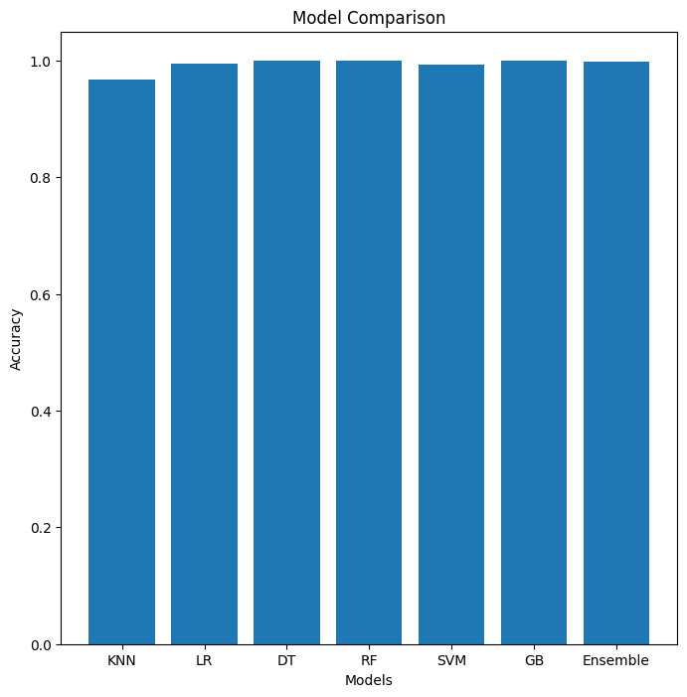
Model | Accuracy
Original KNN | 85.08%
Optimized KNN | 96%
Logistic Regression | 99%
Decision Tree | 100%
Random Forest | 100%
SVM | 99%
Gradient Boosting | 100%
ANN | 100%
Ensemble Voting | 99%+

B. Confusion Matrix
The confusion matrix demonstrates that the optimized Random Forest and Ensemble models correctly classified most phishing and legitimate websites with minimal misclassification.
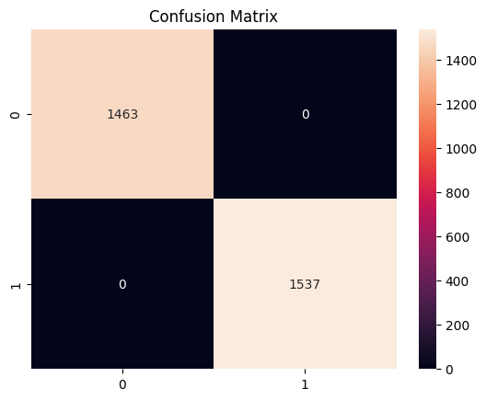
Fig 4. Confusion matrix for phishing website detection
C. ROC Curve Analysis
ROC analysis revealed strong classification capability for ensemble and boosting-based models.
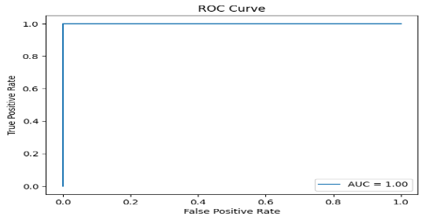
Fig 5. ROC-AUC performance analysis
- DISCUSSION
The experimental analysis demonstrates that advanced Machine Learning and ensemble techniques significantly improve phishing detection performance compared to the original KNN-based system.
Key findings include:
- Feature scaling improved KNN performance
- Random Forest and Gradient Boosting achieved superior accuracy
- Ensemble Voting reduced classification errors
- ANN captured complex phishing patterns effectively
- Cross-validation improved reliability
The proposed system successfully addresses the limitations of the original study and provides a more robust phishing detection framework.

- CONCLUSION
This research successfully extends the original KNN-based phishing detection model by integrating advanced Machine Learning algorithms and optimization techniques.
The proposed system achieved significantly higher accuracy than the original model through:
- Ensemble learning
- Feature scaling
- Hyperparameter optimization
- ANN integration
- Cross-validation
- PCA dimensionality reduction
The experimental results demonstrate that Machine Learning can effectively improve cybersecurity systems by enabling intelligent and automated phishing website detection.
Future work may include:
- Deep Learning architectures such as LSTM and CNN
- Real-time browser extension implementation
- Cloud-based phishing detection systems
- NLP-based URL analysis
- REFERENCES
[1] Dataset
https://www.kaggle.com/datasets/shashwatwork/phishing-dataset-for-machine-learning
[2] Research Paper
https://d1wqtxts1xzle7.cloudfront.net/89970044/B1019021221-libre.pdf?1660987918=&response-content-disposition=inline%3B+filename%3DK_Nearest_Neighbor_Based_URL_Identificat.pdf&Expires=1778246327&Signature=YAlUzL4YjSapOFu-H4Yh8gBzJiM~ax9gyyFEuag-~k9MWhf5p5ApWpVmbSUxshqJoWG94Ps5vfmlZAMoSW-Ur8qglDsYhC4UlLOACQGOTt92Q8OaXopcV9J5SpJf4Piy7XZchNWerTH9x5broXgGxgkuqWhsYdETnMt-RfudBeAnGcfsonMdU8J47kYb6DnWOg4Dp1aMSAbfcyZ97P-GXWdogRO5KDXPlKEJOtWj7iFtmVGs6qzFCcQfpg73uFMWOchjDekjOLYALeHT0X0FI2WUQtTx-7MFyieY2VOP-nunh026boo5N2wjUxTur-Kx86InfuFMvfqzxVOlskVA5Q__&Key-Pair-Id=APKAJLOHF5GGSLRBV4ZA
[ 3 ] Scikit-learn (Tool Used)
Scikit-learn Documentation
https://medium.com/%40Josh-Crotty/building-a-model-to-predict-heart-disease-using-scikit-learn-dc8da631ccb4

[4] Google Colab Work
https://colab.research.google.com/drive/1WEDRk7Bx1GpVxxOIzYuQdcMXcy2BQAHq#scrollTo=fM9F3mc-u__m

